ROCKIN' ROBIN REUNION for MHS '60
MAY 20-21, 2016

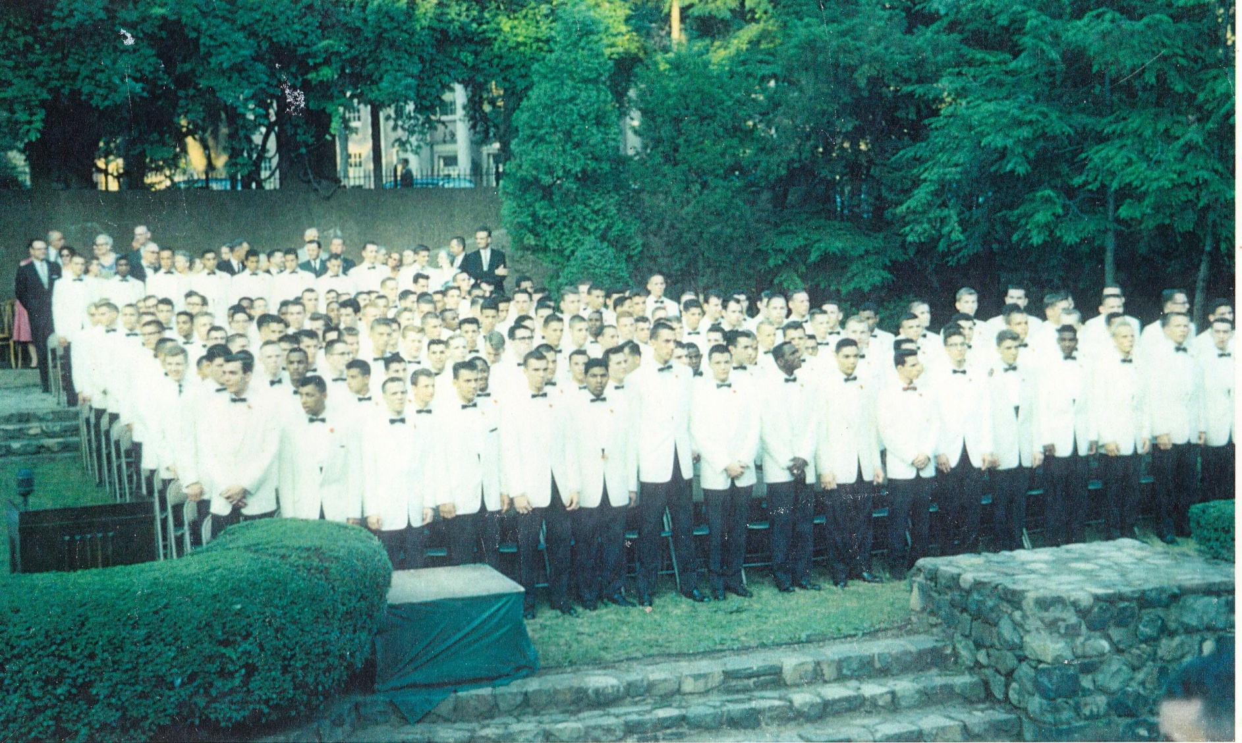
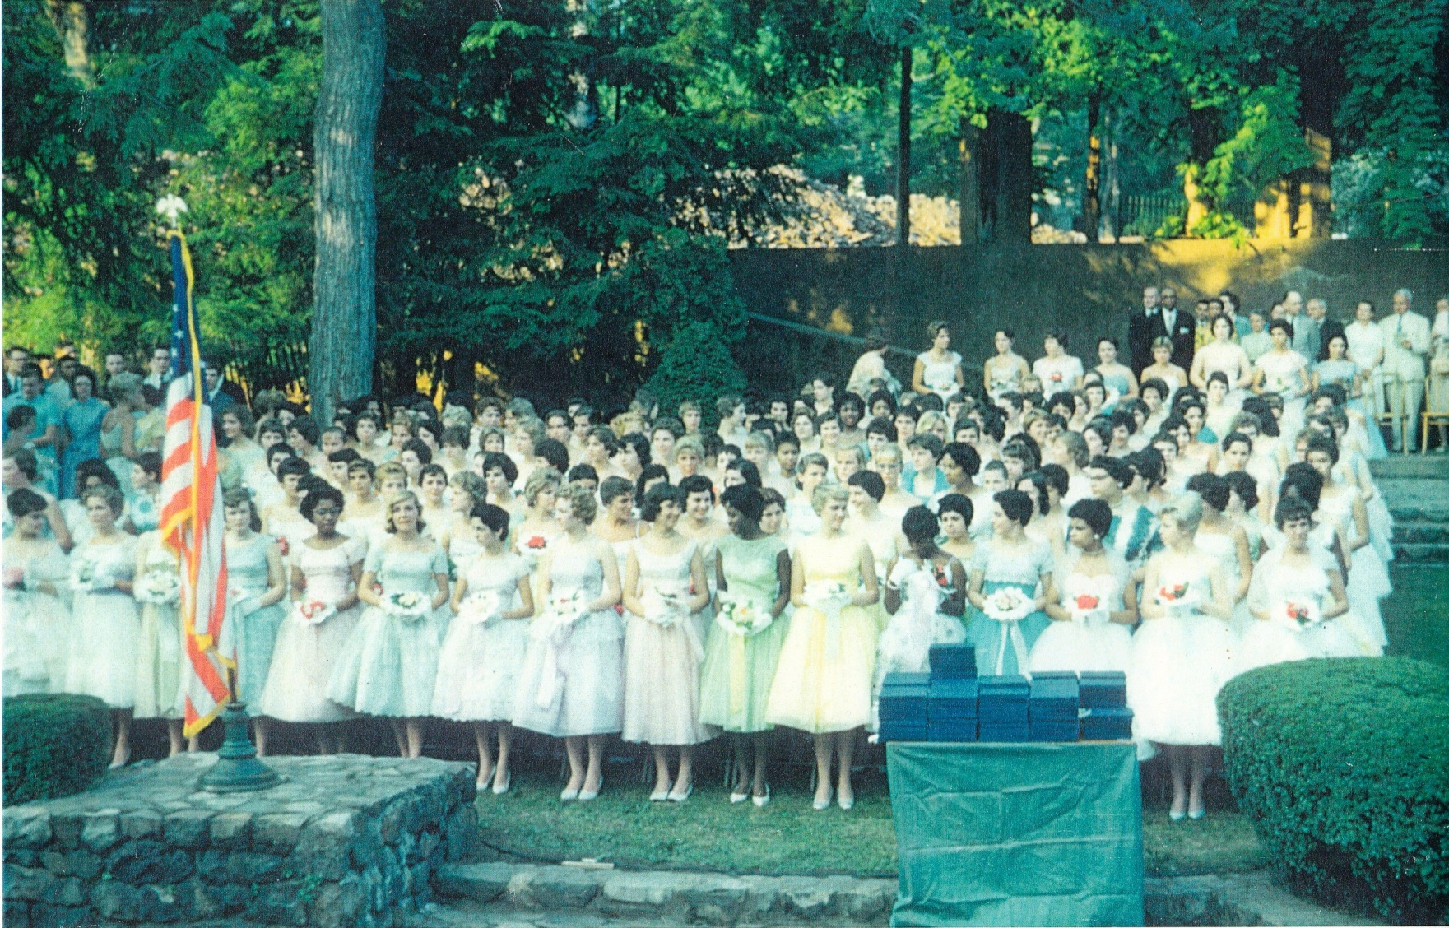

Here we are 56 years ago!
Photo kindness of Susan Becker Knight, whose father was the photographer.

Please sign up for the MHS ’60 Reunion well before May 8.
Send this form along with a check for $80 per person payable to “MHS ’60 Reunion” to:

Frank Rubino
731 Belleville Avenue, Unit B4
Belleville, NJ 07109

Number of Attendees at May 21 Reunion Party @ $80/person ____________________

Your Name (with maiden name if appropriate)

______________________________________________________________________

Street Address _________________________________________________________

City _____________________________________State ___________ Zip __________

Phone______________________________Cell_______________________________

Email _________________________________________________________________

Guest’s (or guests’) full name(s) ____________________________________________
_____ I would like to donate an extra $______________to help with reunion expenses.
_____ I cannot attend reunion, but would like to donate $_____________to class funds.

