ROCKIN' ROBIN REUNION for MHS '60
MAY 20-21, 2016
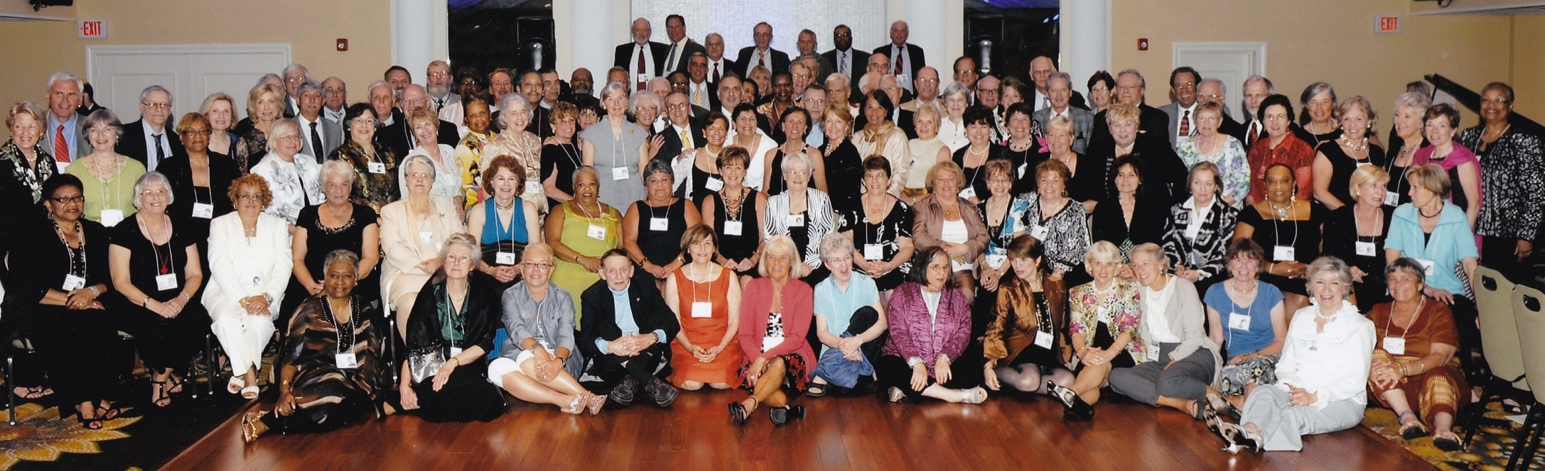IT'S BEEN 6 YEARS SINCE 2010. IT’S TIME TO GET TOGETHER AGAIN!
If you’re in this photo, we’d love to see you again! If you’re not in this photo, we’ve missed you. Please join us.

Daytime May 20 and May 21
This is your time to see your old neighborhood, visit your old haunts, enjoy the Iris Gardens in bloom, visit the Montclair Art Museum, play golf, or whatever. If you like, join classmates gathering for lunch at De Novo European Pub at the Upper Montclair Train Station on Bellevue Ave.

Evening of Friday, May 20
Great Get-Together
WARREN ROSS'S HOUSE: 105 Clinton Avenue, Montclair, NJ 07042
Time: 6:30 pm
Cost: Free, but feel free to throw a few dollars into the pot to cover drinks, cups, and plates.
Food and drink: Local classmates are encouraged to bring a little food to share.
Attire: Casual.

Evening of Saturday, May 21
Reunion Party
MONTCLAIR GOLF CLUB: 25 Prospect Avenue, West Orange, NJ 07052
Time: 6:00-11:00 pm
Cost: $80.00 per person
Food: Heavy hors d’oeuvres and delicious desserts.
Cocktails. Each person will receive a ticket for one “free" bar beverage. Cash bar after that.
DJ: JJ The DJ
Attire: Country Club Casual. Men: Jackets, no ties / Slacks, no jeans. Women: No jeans.

For golf: Contact Rick Boschen, flrickb2@yahoo.com
For information about hotels, lots of restaurants, and more, see www.montclair60.com
Or contact: Nan Peppard, npepcar@yahoo.com or Rosemary DiGeronimo roesternbach@aol.com

Please make your reservation for Reunion by May 8.

